NT Assignment Security
  - Giel Willemsen, Casey Stijlaart T-CB-COM3-T3-CB01 24-09-2021
Task 1: Hashing
With the help of hashing it is easier to detect changes inside data. To see how much hashes can very when a slight change has been made, we used the provided plain text file and went from there. The hash from the untouched plain text file is as following; MD5(alice.txt)= 94e10e8c6b62c921f30a5429afc2d817 . This hash will not be influenced when the plain text file is copied, since there has no alternations been made. Non the less, it does change when the file has been modified. Even the smallest change within a file changes the hash drastically, see Figure 1 : Hashing.

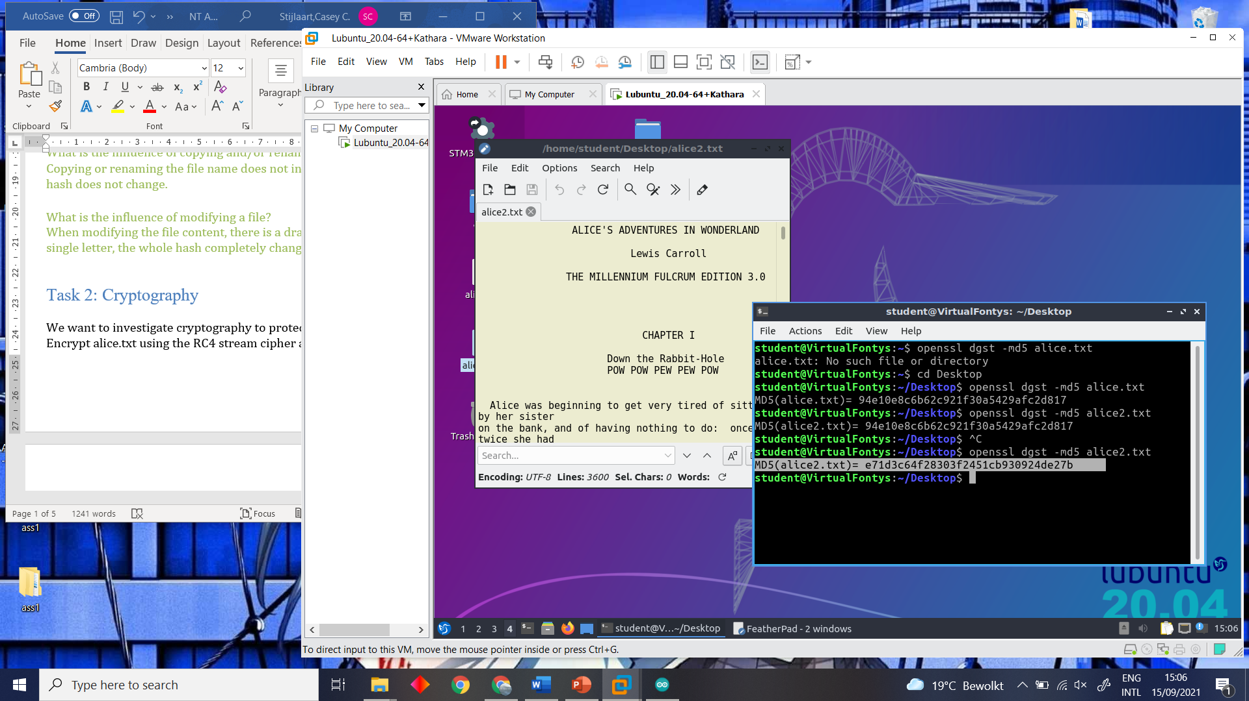
Figure 1 : Hashing.

Task 2: Cryptography
With the help of cryptography our data is more protected. To understand how cryptography exactly works, we made use of the openssl command functions to encrypt the plain text file. To put this into practise, we encrypted the plain text file from task 1 in two different ways ( rc4 and aes), to say how much the encrypting algorithm differs from each other. When the file is encrypted, it gets stored into a newly created data file, this data file is not plain text anymore but is now binary data. To decrypt the binary data we made use of the openssl command functions once again. The used commands are as following; “openssl enc -d -rc4 -in alice.rc4 -out alice3.txt” and “openssl enc -d -aes-256-cbc -in alice.aes -out alice4.txt”.

The encrypted files are slightly larger than the plain text but when decrypted the resulting file is the same again. This has to do with the window size of the encryption algorithm so some padding is included. This can be explained due to the fact that when decrypting the encrypting file went correctly, it should return the data of the original input file. Therefor we also checked if this was the case. This could simply be done by hashing the three files and compare it’s hash, see Figure 2 : Hash cryptography. With the help of the figure we can conclude that the encryption and decryption went correct.

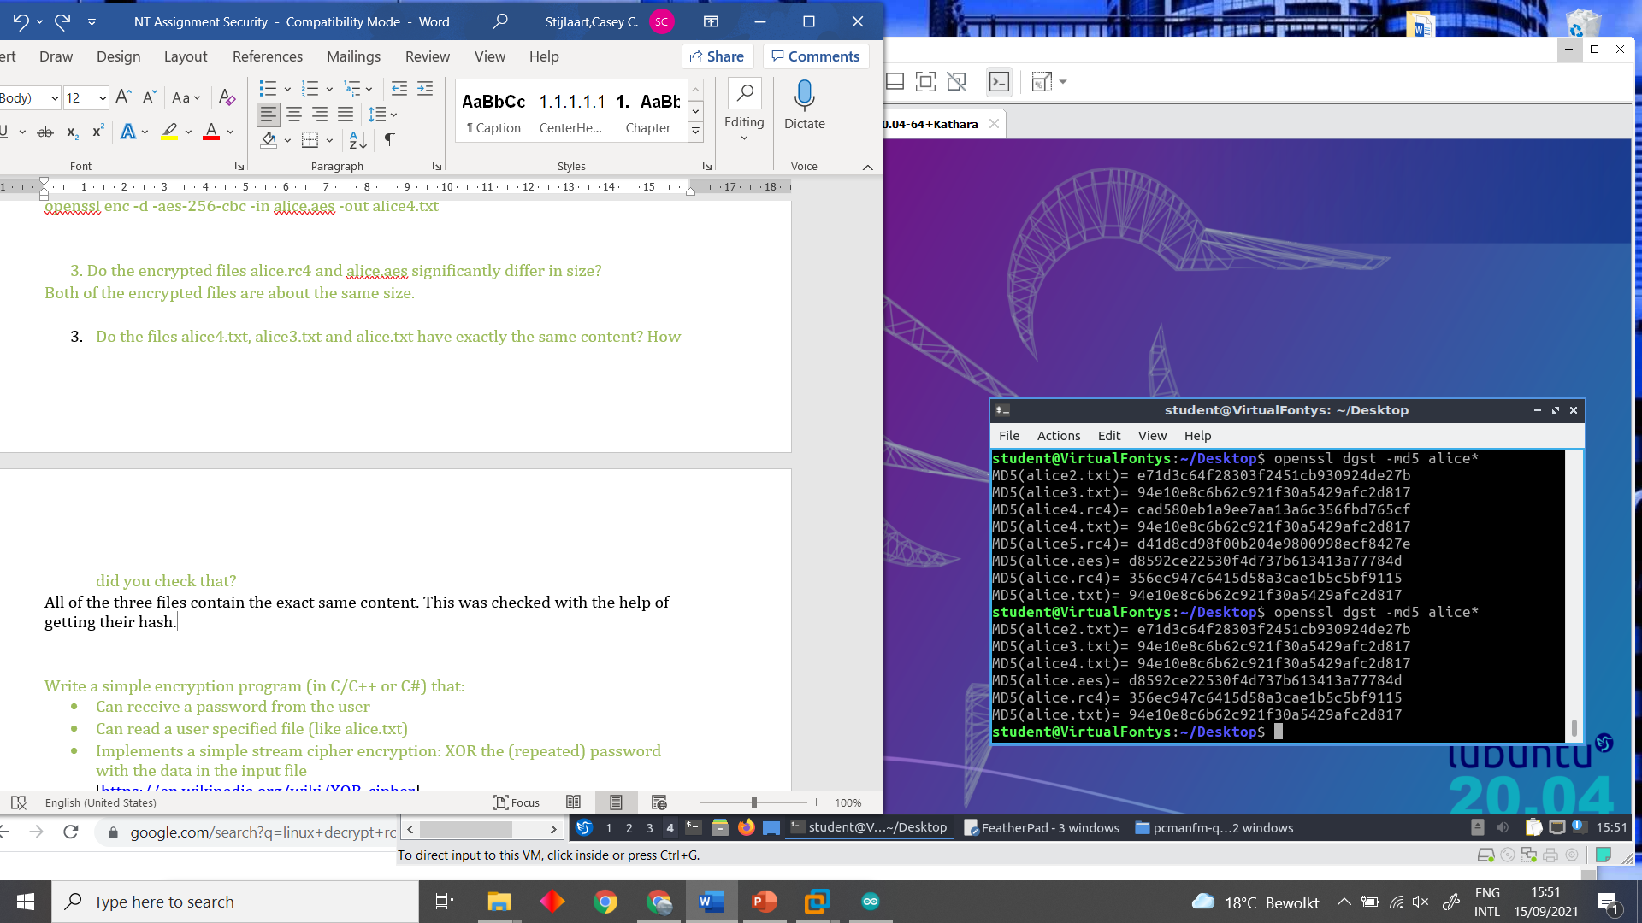
Figure 2 : Hash cryptography.

To get an even better understanding of encryption, we created a simple C# program and C program to encrypt and decrypt with the help of an input file and key. Here for we refer you to the other files within the ZIP folder.

Task 3: Authentication
Certificates are used for authentication and could also be used to implement a secure version of HTTP, HTTPS. To investigate the use of certificates, we are running an Apache server on our Linux host. Without any configuration, there is no possibility to successfully make use HTTPS. This could be shown with the help of trying to connect to http://localhost, and https://localhost. See Figure 3 : Certificate authentication.

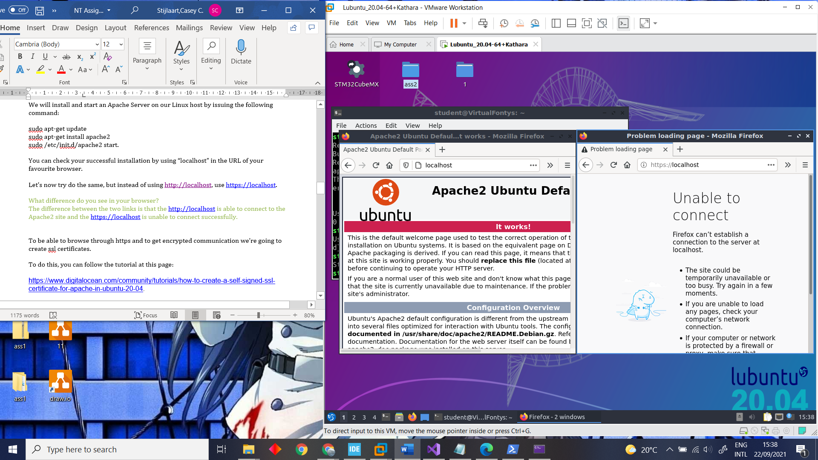
Figure 3 : Certificate authentication.

In order to be able to connect to the HTTPS and get encrypted communication there needs to be a ssl certificate created. To achieve this we followed the tutorial on the following page; https://www.digitalocean.com/community/tutorials/how-to-create-a-self-signed-ssl-certificate-for-apache-in-ubuntu-20-04.

After following the tutorial we tried to connect to the https://localhost again. This time we first got a warning about the connecting not being secure, since it is an self-assigned certificate, see Figure 4 : Certificate warning. When going further to the https we were able to see the site, see Figure 5 : https://localhost

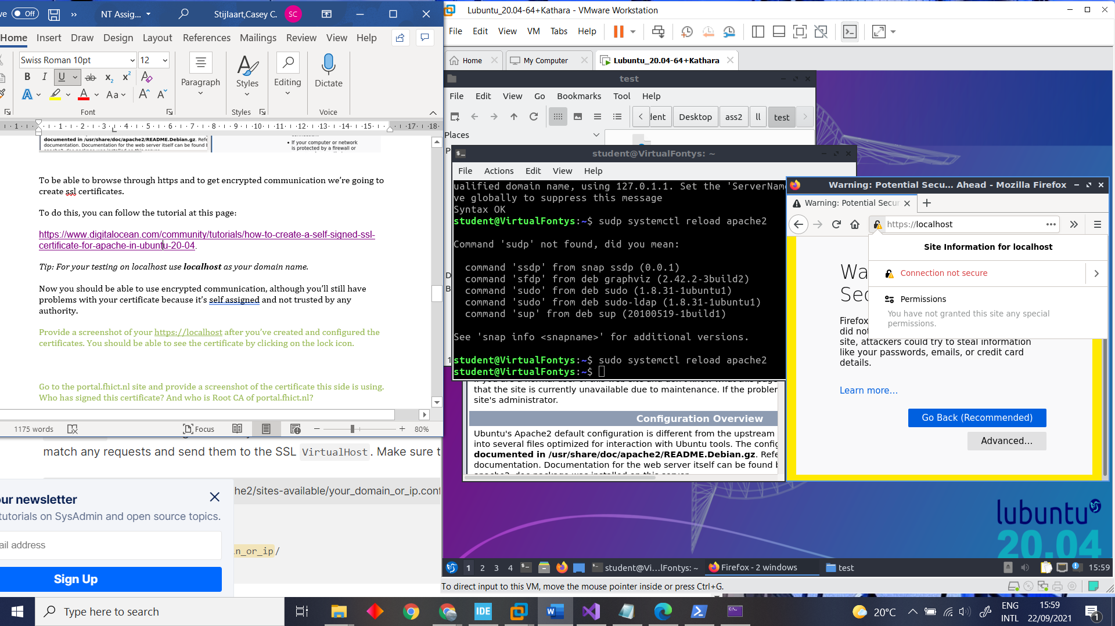
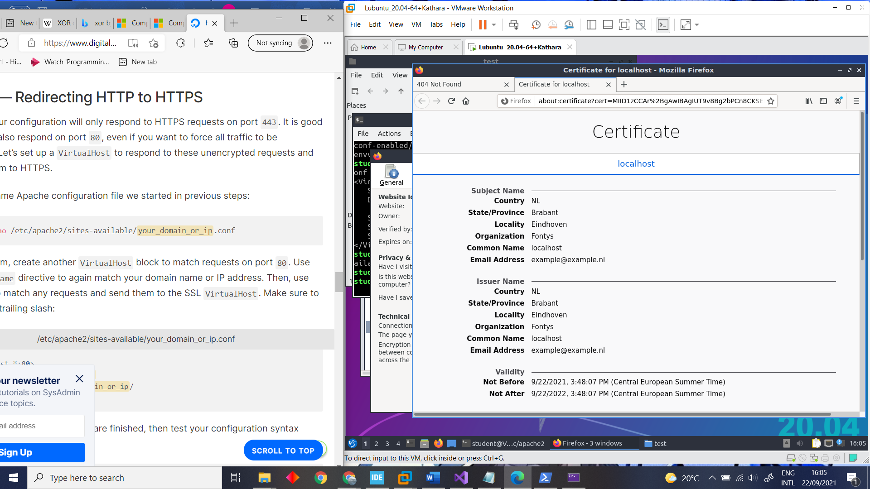
Figure 4 : Certificate warning.
Figure 5 : https://localhost
With the help of knowing how to see the certificate of a specific HTTPS, we could also use this on other site. For example when looking at portal.fhict.nl we can conclude the following;

The certificate is signed by GEANT vereniging, GEANT OV RSA CA 4. Regarding to the root CA we came to the findings that on windows microsoft edge we got a different root authority then on Ubuntu Firefox. See Figure 6 : Certificates Ubuntu. and Figure 7 : Certificate Windows.
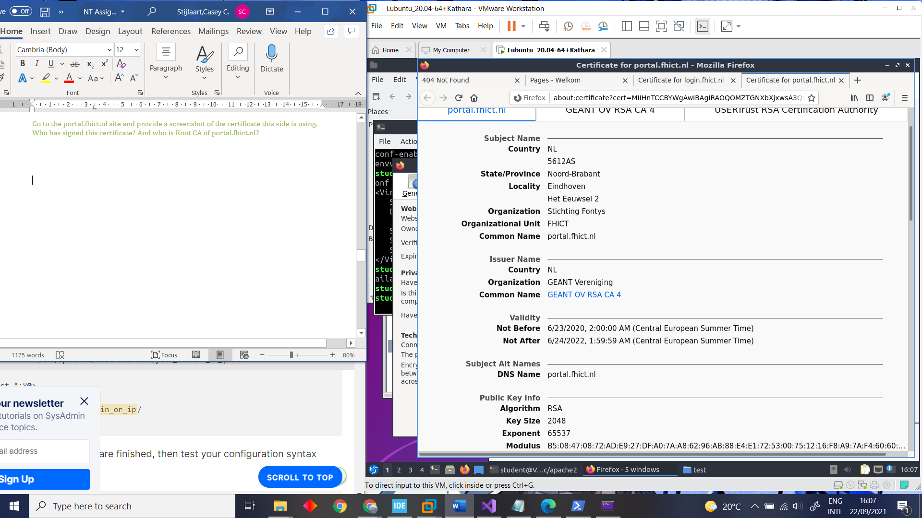
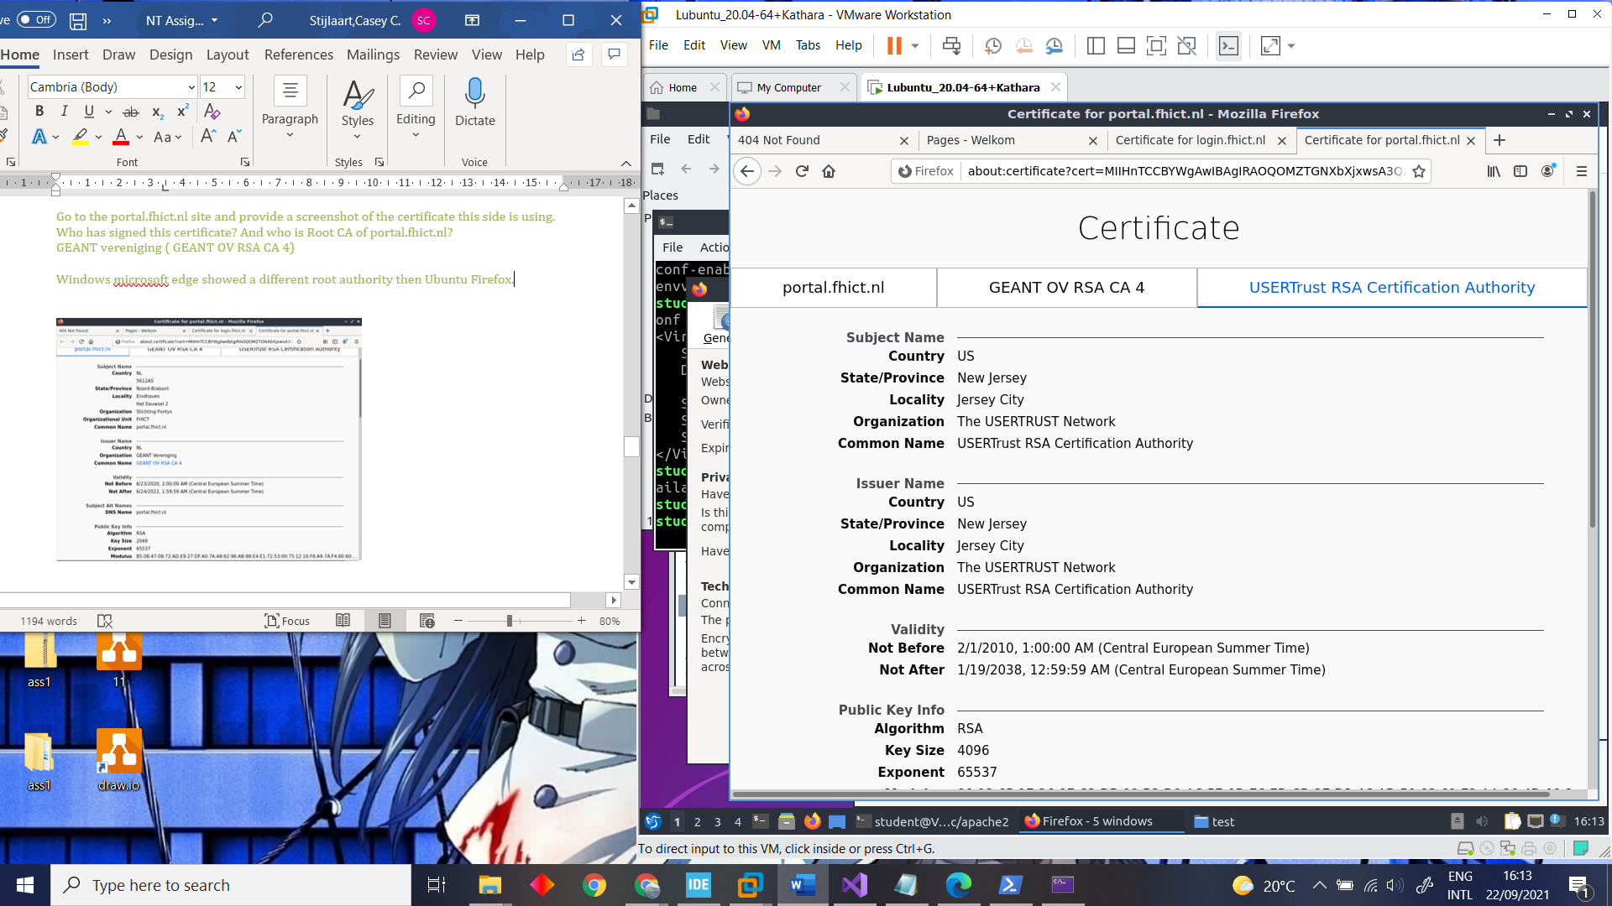
Figure 6 : Certificates Ubuntu.

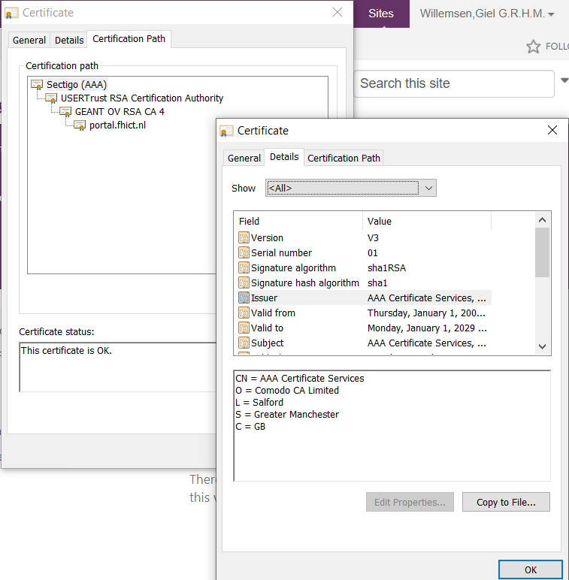
Figure 7 : Certificate Windows.

Task 4 (Optional): Configure Firewall on Linux/Netkit
In the last task we took a closer look on how to configure firewall on Linux. Therefor we used the kathara_labs which has been provided to us in the previous assignments. To get the lab up and running, we had to make some changes regarding to the router and server. We had to configure the router to provide the gateway to the DHCP clients. And the server also needed the gateway and since the server has a static network configuration we have to add the gateway to the interface file of the server. For the DHCP gateway it will point to the IP of the router in the IP network of the DHCP, and for the server it will point to 195.20.1.254 since that is the IP of the router in the servers’ network. After the configuration we looked more into how we could configure a firewall, this could be done with the help of the iptables command functions. Knowing this, we started off with using an command in the router, which would result in the server being unable to reach PC1. The command which we used to do this is “iptables –append -s 192.168.1.10 -j DROP”. To display that the new rule was entered correctly and resulted in what we wished for, we used iptables --list to see if the new rule was added, then we also checked if the server wasn’t able to ping PC1 anymore. See Figure 8 : iptables --list. and Figure 9 : PC1.
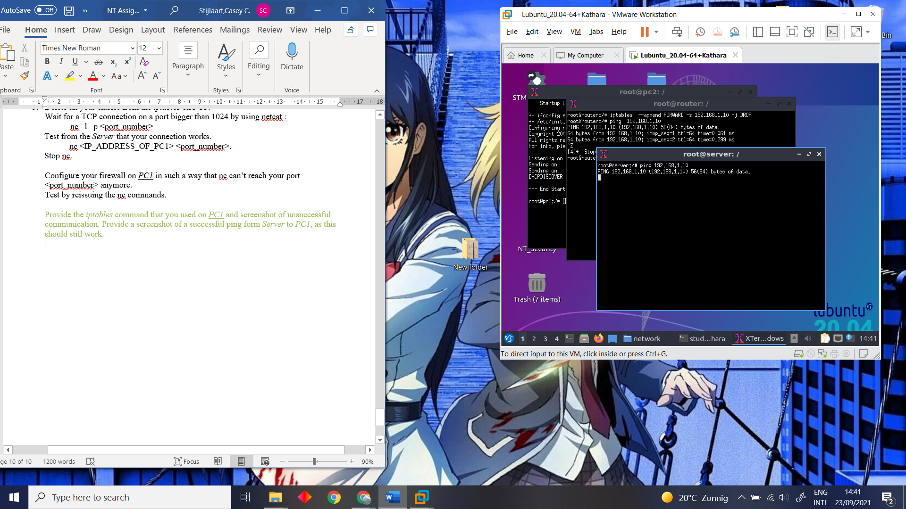
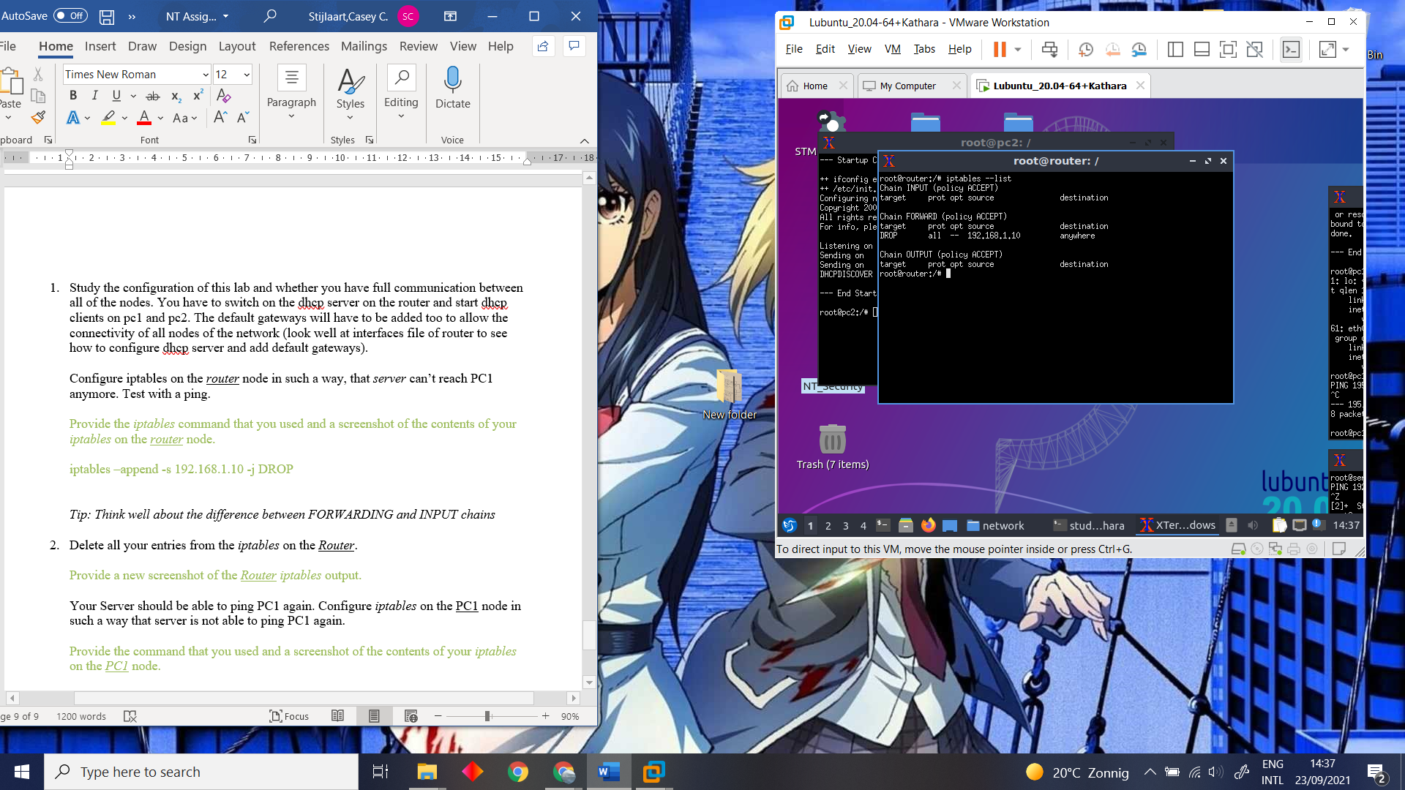
Figure 8 : Ping PC1.
Figure 9 : iptables --list.

To delete all the entries and rules we had given, we used iptables --flush. To check if the entries and rules are actually deleted, there could be made use of the same command as in Figure 10 : iptables after flushing.
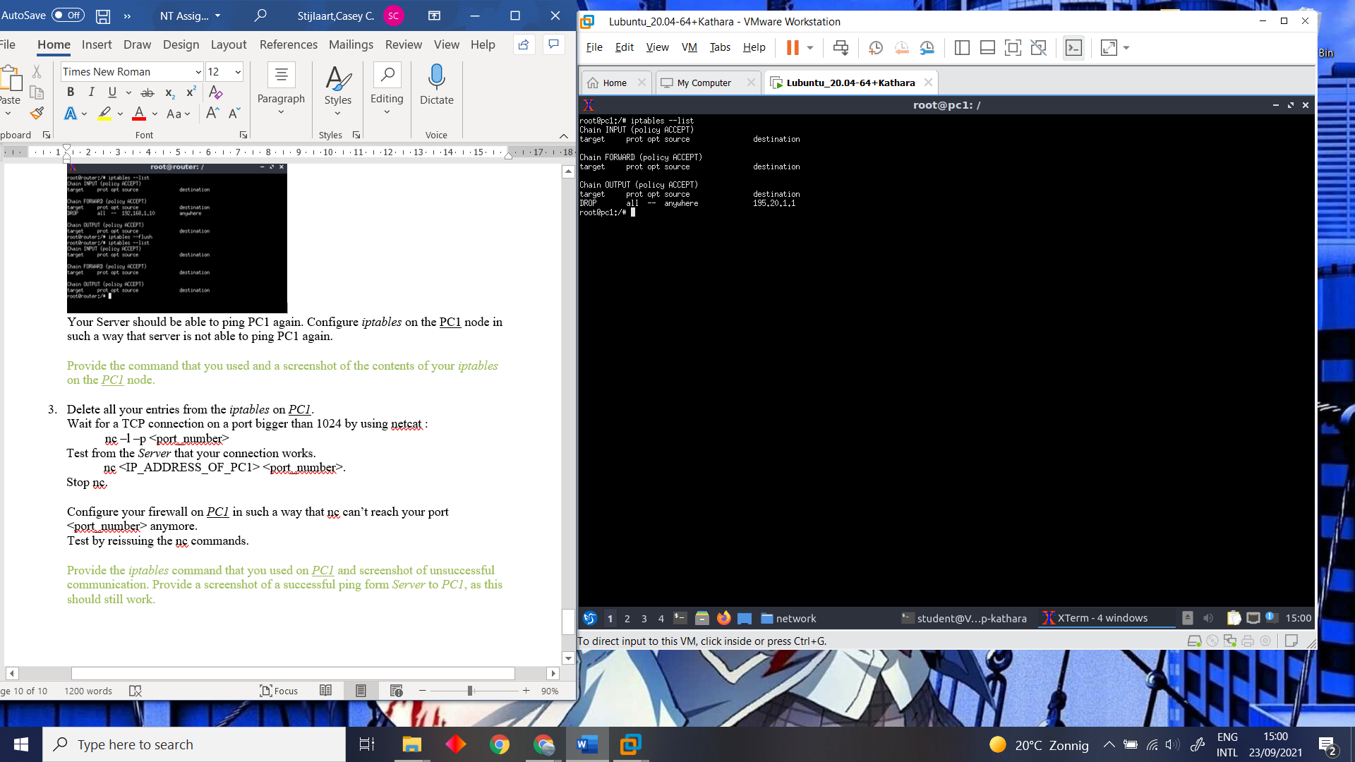
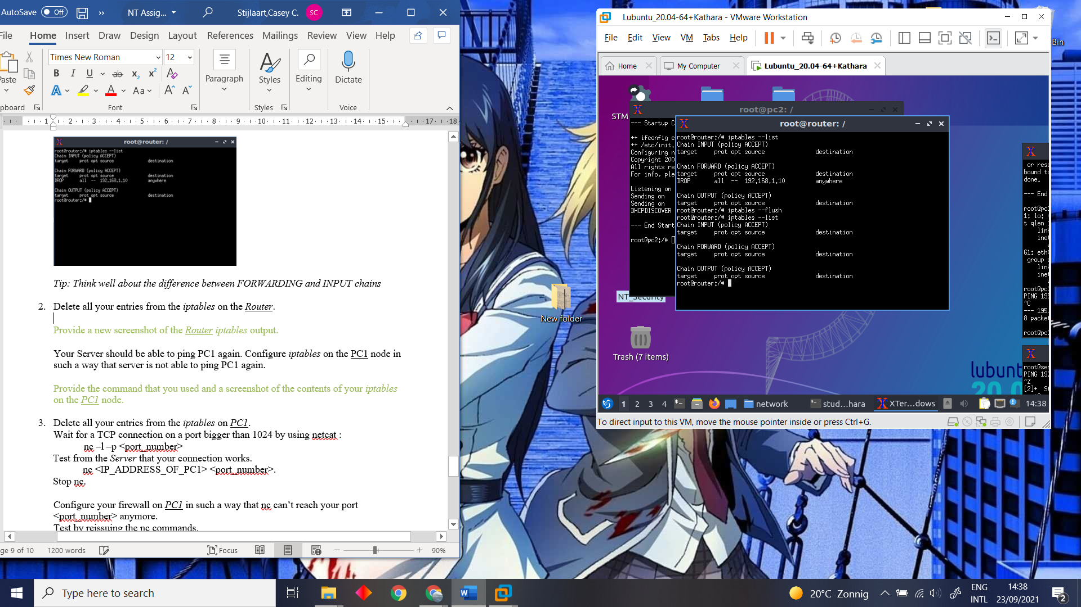
Figure 10 : iptables after flushing.
Figure 11 : iptables on PC1.

As previously done, we made the server unable to connect to PC1, but this time from the PC1 iptables. To get the same result we used the following command; “iptables -–append OUTPUT -d 195.20.1.1 -j DROP”. By using the iptables --list command once again, we checked if the configuration went how we expected it to. See Figure 11 : iptables on PC1.

Lastly, we tried to block a specific TCP connection by configuring the firewall of PC1 in such a way. Therefor the command we used is “iptables -A INPUT -p tcp –dport 1024 -j DROP”. To see if the configuration was successful we used the same command as before. Besides that we also tried to ping from the server to PC1, since this should still work. See Figure 12 : Unsuccessful TCP. and Figure 13 : Ping Server to PC1.

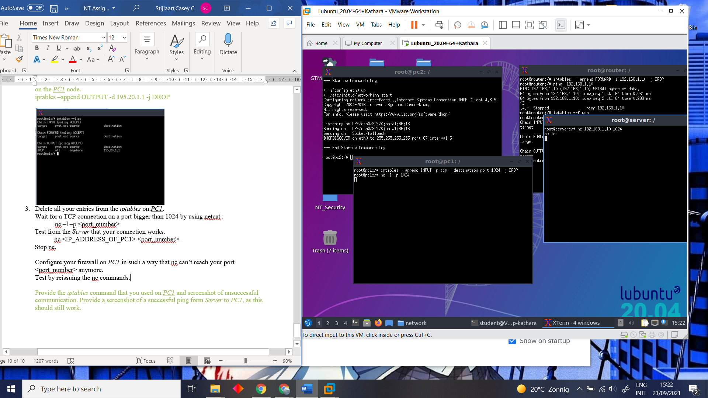

Figure 12 : Unsuccessful TCP.

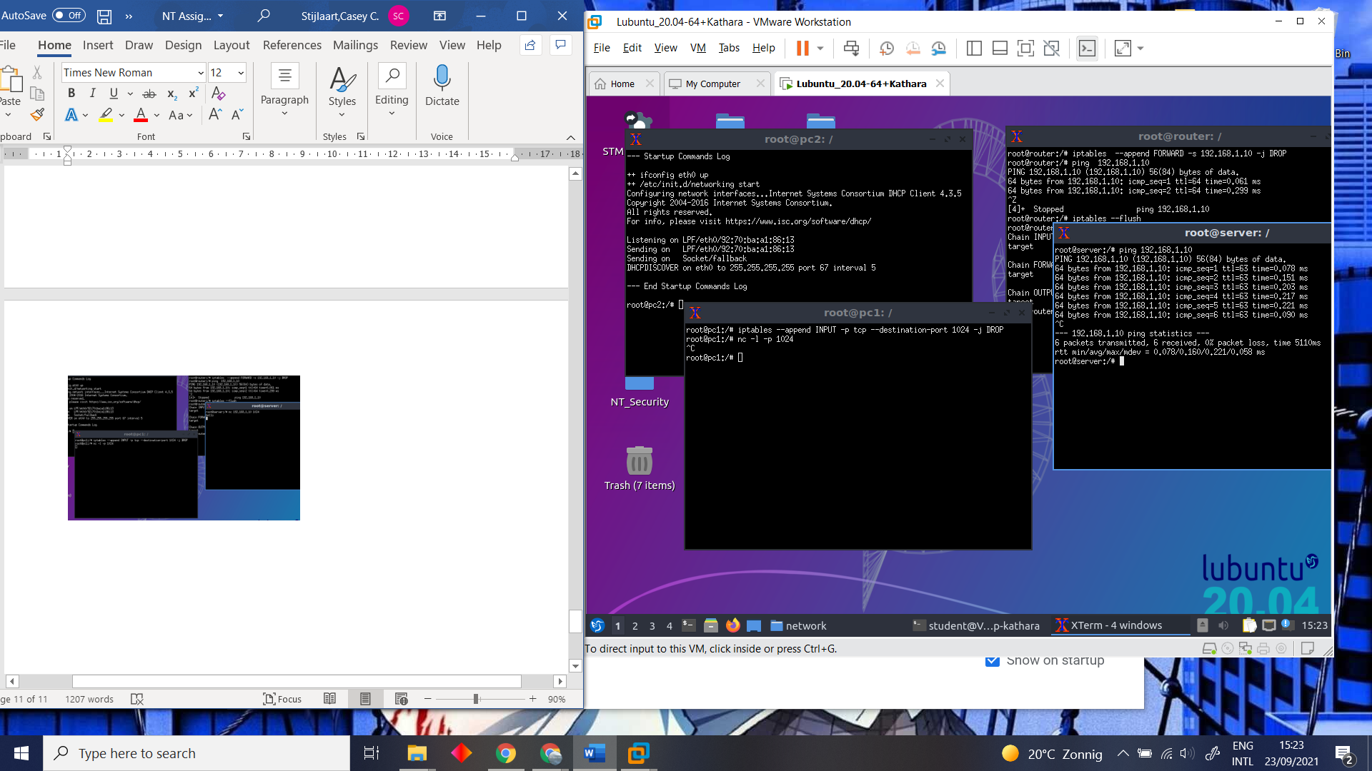
Figure 13 : Ping Server to PC1.

